**Bikes Sales Analysis**

Based on the analysis performed on the Bike Sales data set (<https://colab.research.google.com/drive/1KAnYogKM6RnRt4ZEjyeVAVxG0I3PxLUO#scrollTo=VKSmXlR5QuyO>), I was able to find these valuable insights:

* 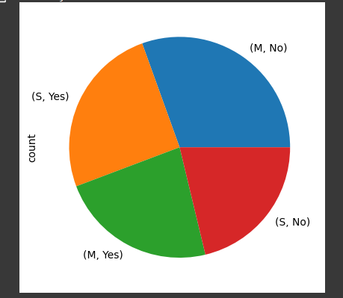Majority of the bikes are purchased by the people who are single.
* People with 0 kids or at-least 2 kids are the majority who are purchasing bikes.

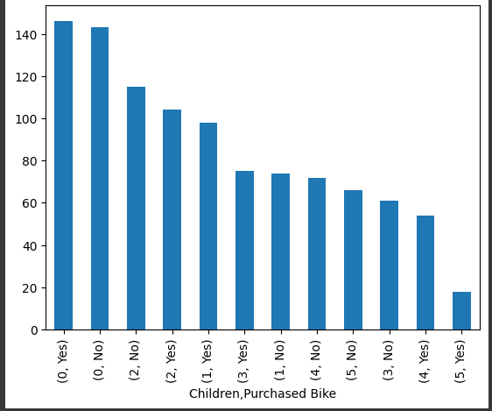

* The majority of the bike buyers are either Professionals or Skilled Manual

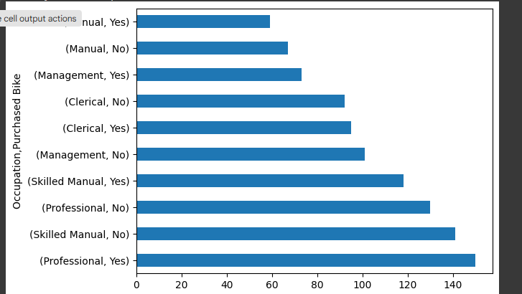

* Most people who are buying bikes are the ones who’s commute distance is less than 1 Miles

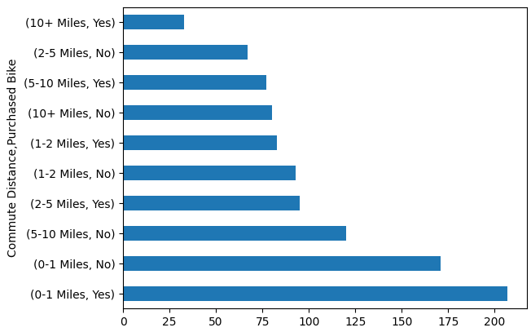

**Final conclusion to improve sales for future:  
>** Target **Men** customers who are **Single** and who’s **Daily commute** is less than 1 miles by running ads/offers and focusing on highlighting the cost benefits of owning a 2-Wheeler rather than a 4-Wheeler and the amount of gas money they can save by riding a bike.